**Taxi Schedule**

***Work-flow to Use Taxi Schedule***

The Taxi Schedule preference is accessed through **Load Template**



There is only one template available, and only one instance of it is permitted



***Preference Overview***

Driver shuttles may operated by the drivers themselves as part of a duty (instead of a third party). This preference sets driver shuttle (taxi) schedule strategy.

***Templates Available from Optibus***

***Driver Duty Work Time Preference***

**Purpose:**

As stated in the Overview. **Prerequisites:** None. **Opening Dialog:**

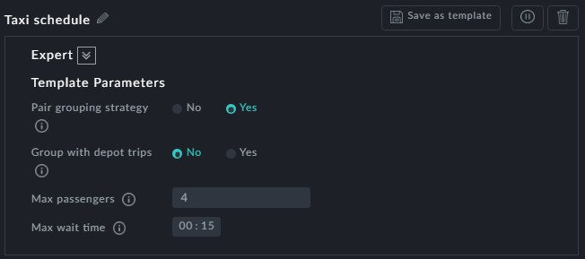

**Points to note:**

**Pair grouping strategy**: When set to Yes, shuttles are driven by drivers as part of their duty and there is no need for specific shuttle scheduling (duties or drivers)



**Group with depot trips**: When set to Yes, shuttle trips a re grouped with depot pull out/pull in trips.



You cannot use **Group with depot trips** with **Pair grouping strategy** set

to Yes.

**Max passengers**: This is the maximum number of passengers in a shuttle trip, includ-



ing the driver

**Max wait time**: This is the maximum time that a driver may wait for a shuttle before or after his duty.

